|  |
| --- |
| IanJsutherland.com |
| Better Sponsor Engagement |
| A simple aid to eliminating misalignment between Sponsor and Project Manager |
|  |
| **Ian Sutherland** |
| **February 2015** |

**Background**

* **The two most important people in a project are the sponsor and the project manager**
* **The biggest single cause of breakdown in the management of a project or change initiative is a mismatch between the expectations of the sponsor and their project manager**
* **This is usually the result of**
  + **overlaps and clashes between their respective efforts; or**
  + **the omission/poor performance of key project activities as each expects the other to address them**
* **When this happens it is easier for a sponsor to have the project manager changed than it is for the project manager to change the sponsor, hence it is beholden on the project manager to solve this issue before problems develop**
* **It should be noted that the project manager as the change professional is likely to be better informed about good practice when it comes to project governance. In contrast this activity may be only a small part of the sponsor’s overall responsibilities and is often new to the individual.**

**The Proposition**

* **It is important to ensure that the sponsor and project manager are aligned from a very early stage**
* **The attached paper is designed to encourage and facilitate a conversation between a project manager and their sponsor that will help clarify what each will contribute and thus what each can expect from the other while working together**
* **The document and this process are intended to be catalytic and not totally prescriptive**
* **Points can be moved and added as long as both parties agree, but**
* **I would counsel against removing points entirely unless you are both sure they are covered elsewhere.**
* **The paper can be rebranded to suit the environment in which it will be used**
* **The tri-fold format promotes a less-formal style of discussion and has regularly been better received and more effective than a standard A4 memo**

**Recommended Use**

* **Edit/Amend the last two pages if needed**
* **Print the last two pages of this document in colour and double sided**
* **Fold into its tri-fold form as follows**
  + - 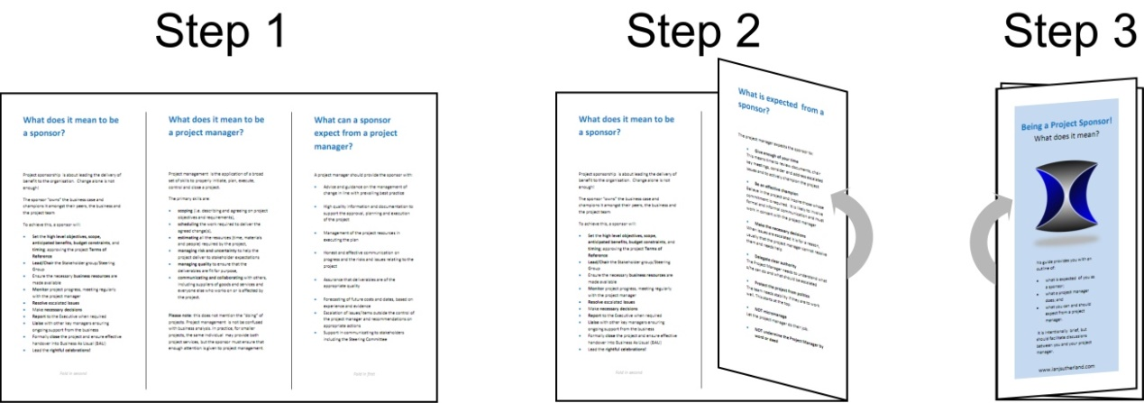
* **Arrange a meeting with the sponsor. Present the trifold and talk through the points**
* **Agree any changes that you believe are relevant**
* **If there are points you cannot agree on engage the help of your PMO, Head of Change or similar to arbitrate and resolve matters**
* **Revise/rebrand elements and re-issue**
* **Revisit as necessary during the project**

**Conclusion**

* **The key to improved engagement and better outcomes depends heavily on an alignment of expectations between the sponsor and the project manager**
* **This paper provides the project manager with way to open discussion the sponsor about their respective roles and expectations**
* **There are no sacred cows so the reader should feel free to adapt the materials to better suit their needs and environment**
* **Warnings**
  + **Don’t use too much jargon in the conversations**
  + **Don’t compromise to the point where you lose integrity**
  + **Seek help if you feel agreement has not / cannot be reached**
* **This approach has proved useful on many occassions, but is not a one-shot play. Revisit the content with the sponsor if you believe alignment is slipping**

**Good luck!**

For further information or advice contact [Info@IanJSutherland.com](mailto:Info@IanJSutherland.com) / +44 7917 190635

**The Tri-Fold**

**What is expected from a sponsor?**

The project manager expects the sponsor to:

* **Give enough of your time**

This means time to review documents, chair key meetings, consider and address escalated issues and to actively champion the project

* **Be an effective champion**

Believe in the project and inspire those whose commitment is required. It is likely to involve formal and informal communication and must work in concert with the project manager

* **Make the necessary decisions**

When issues are escalated it is for a reason, usually that the project manager cannot resolve them and needs help

* **Delegate clear authority**

The Project Manager needs to understand what s/he can do and what should be escalated

* **Protect the project from politics**

The team needs stability if they are to work well. This starts at the top

* **NOT micromanage**

Let the project manager do their job

* **NOT undermine the Project Manager by word or deed**

**Some tips on being a good sponsor**

Projects are by definition original activities and outcomes are never certain. Here are some tips that will make success more likely:

* Make sure you are **engaged** from start to finish
* Do not rely on **untested assumptions**
* Understand the **sensitivities** in the project; ie what presents the greatest risk to success
* **Use your project manager** and best practices
* Don’t set **unreasonable timetables**
* Make any **required decisions** in a timely manner, undue delay usually adds to the project difficulty
* **Communicate**, communicate, communicate and **listen**
* **Believe** and be seen to believe in the project and the solution; if you don’t why should anyone else?
* **Support** the project team

**Being a Project Sponsor!**

What does it mean?



This guide provides you with an outline of:

* what is expected of you as a sponsor;
* what a project manager does; and
* what you can and should expect from a project manager.

It is intentionally brief, but should facilitate discussions between you and your project manager.

www.ianjsutherland.com

**What does it mean to be a sponsor?**

Project sponsorship is about leading the delivery of benefit to the organisation. Change alone is not enough!

The sponsor “owns” the business case and champions it amongst their peers, the business and the project team

To achieve this, a sponsor will:

* Set the **high level objectives, scope, anticipated benefits, budget constraints**, and **timing**; approving the project **Terms of Reference**
* **Lead/Chair** the Stakeholder group/Steering Group
* Ensure the necessary **business resources** are made available
* **Monitor** project progress, meeting regularly with the project manager
* **Resolve** escalated **issues**
* Make **necessary decisions**
* **Report** to the Executive when required
* **Liaise** with other key managers ensuring ongoing support from the business
* Formally **close** the project and ensure effective handover into Business As Usual (BAU)
* Lead the **rightful celebrations!**

*Fold in second*

**What does it mean to be a project manager?**

Project management is the application of a broad set of skills to properly initiate, plan, execute, control and close a project.

The primary skills are:

* **scoping** (i.e. describing and agreeing on project objectives and requirements)
* **scheduling** the work required to deliver the agreed change(s)
* **estimating** all the resources (time, materials and people) required by the project
* **managing risk and uncertainty** to help the project deliver to stakeholder expectations
* **managing quality** to ensure that the deliverables are fit for purpose
* **communicating and collaborating** with others, including suppliers of goods and services and everyone else who works on or is affected by the project

**Please note**: this does not mention the “doing” of projects. Project management is not be confused with business analysis. In practice, for smaller projects, the same individual may provide both project services, but the sponsor must ensure that enough attention is given to project management.

**What can a sponsor expect from a project manager?**

A project manager should provide the sponsor with:

* Advice and guidance on the management of change in line with prevailing best practice
* High quality information and documentation to support the approval, planning and execution of the project
* Management of the project resources in executing the plan
* Honest and effective communication on progress and the risks and issues relating to the project
* Assurance that deliverables are of the appropriate quality
* Forecasting of future costs and dates, based on experience and evidence
* Escalation of issues/items outside the control of the project manager and recommendations on appropriate actions
* Support in communicating to stakeholders including the Steering Committee

*Fold in first*